Networking
Module 1&2 Assignment :
Questions :
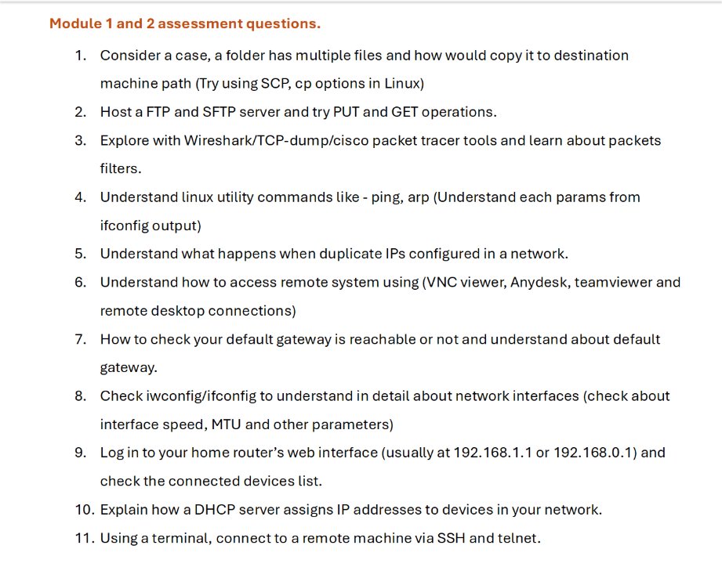

Answers :

- Cp command
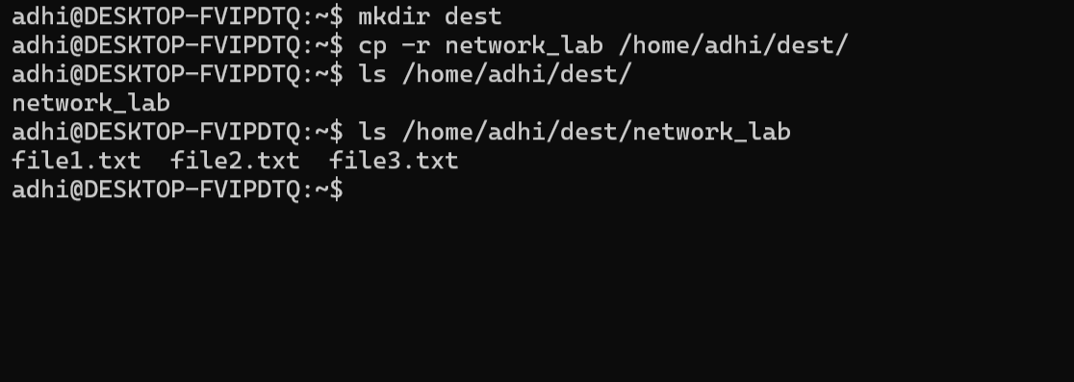Scp command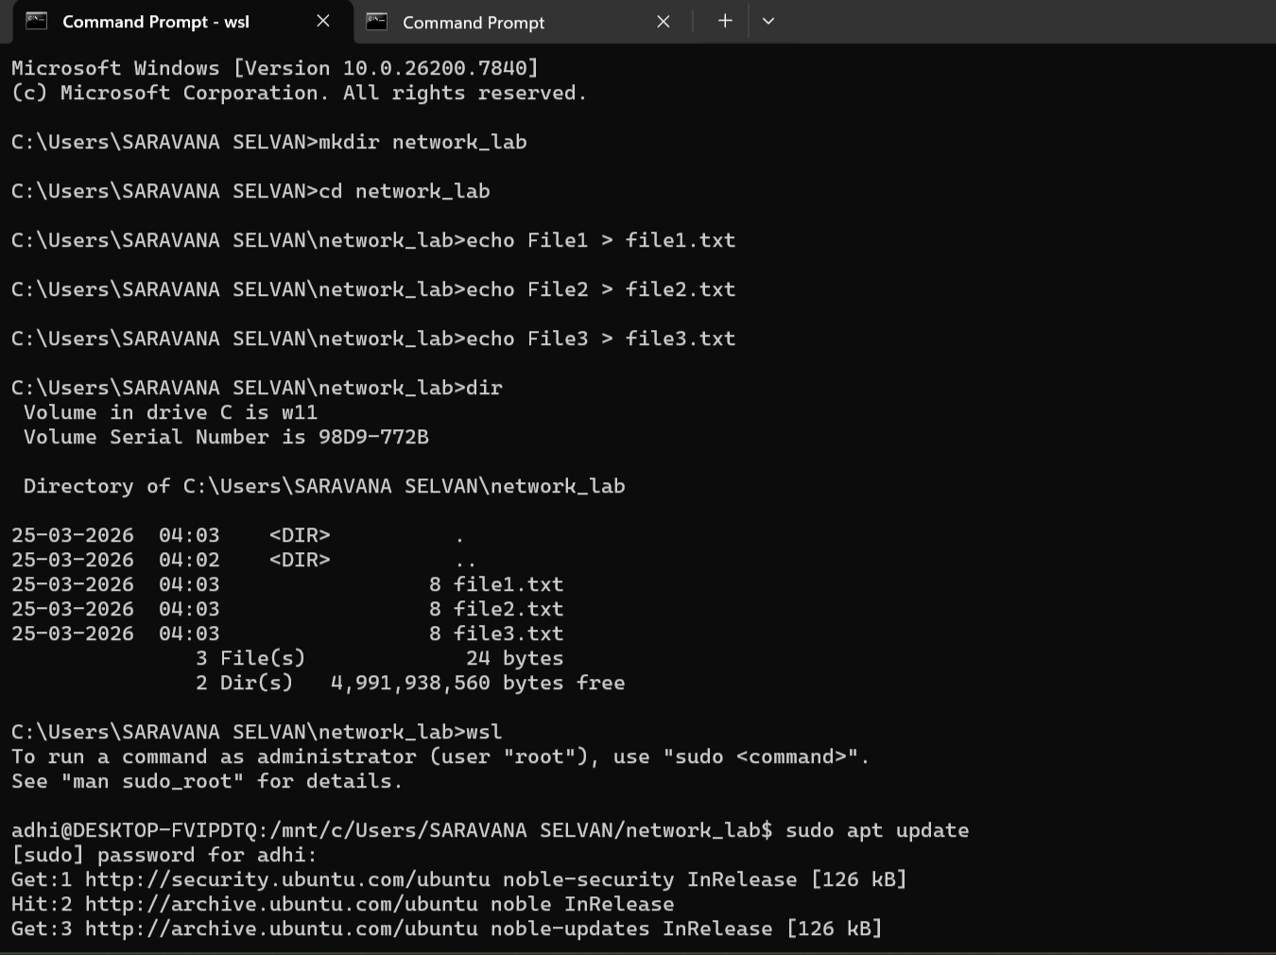
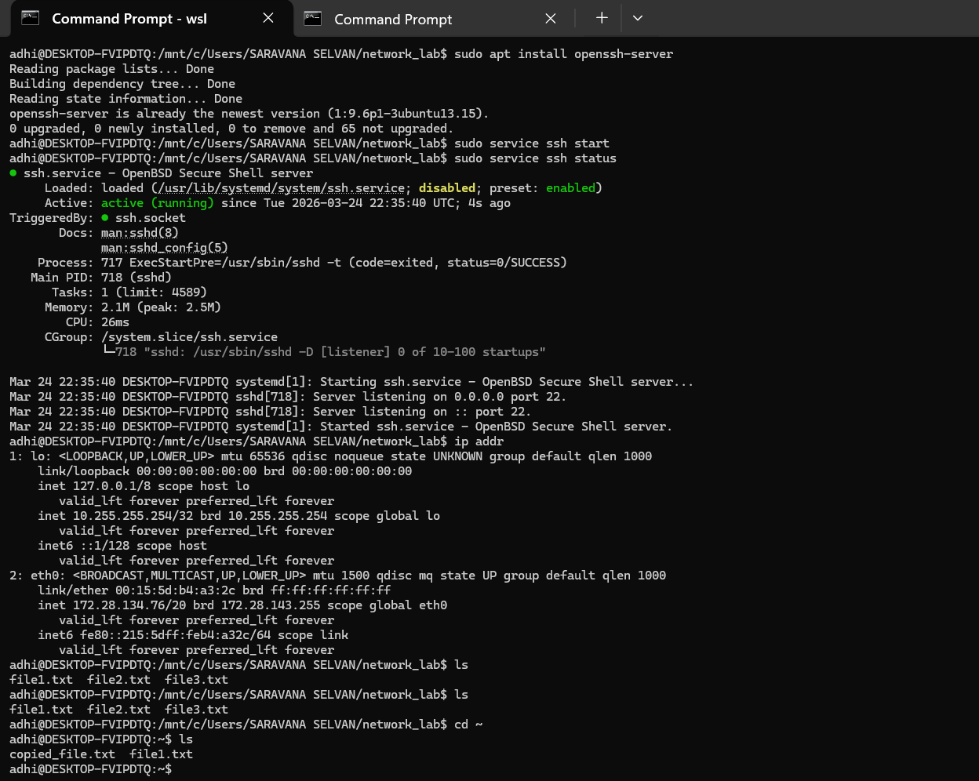
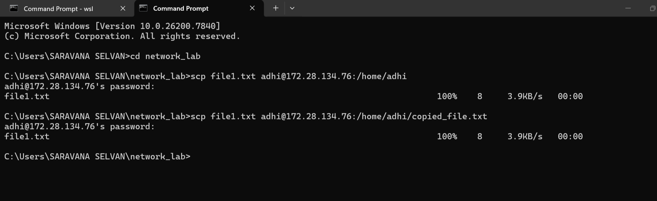
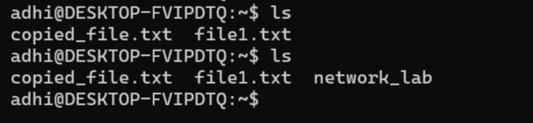
2.
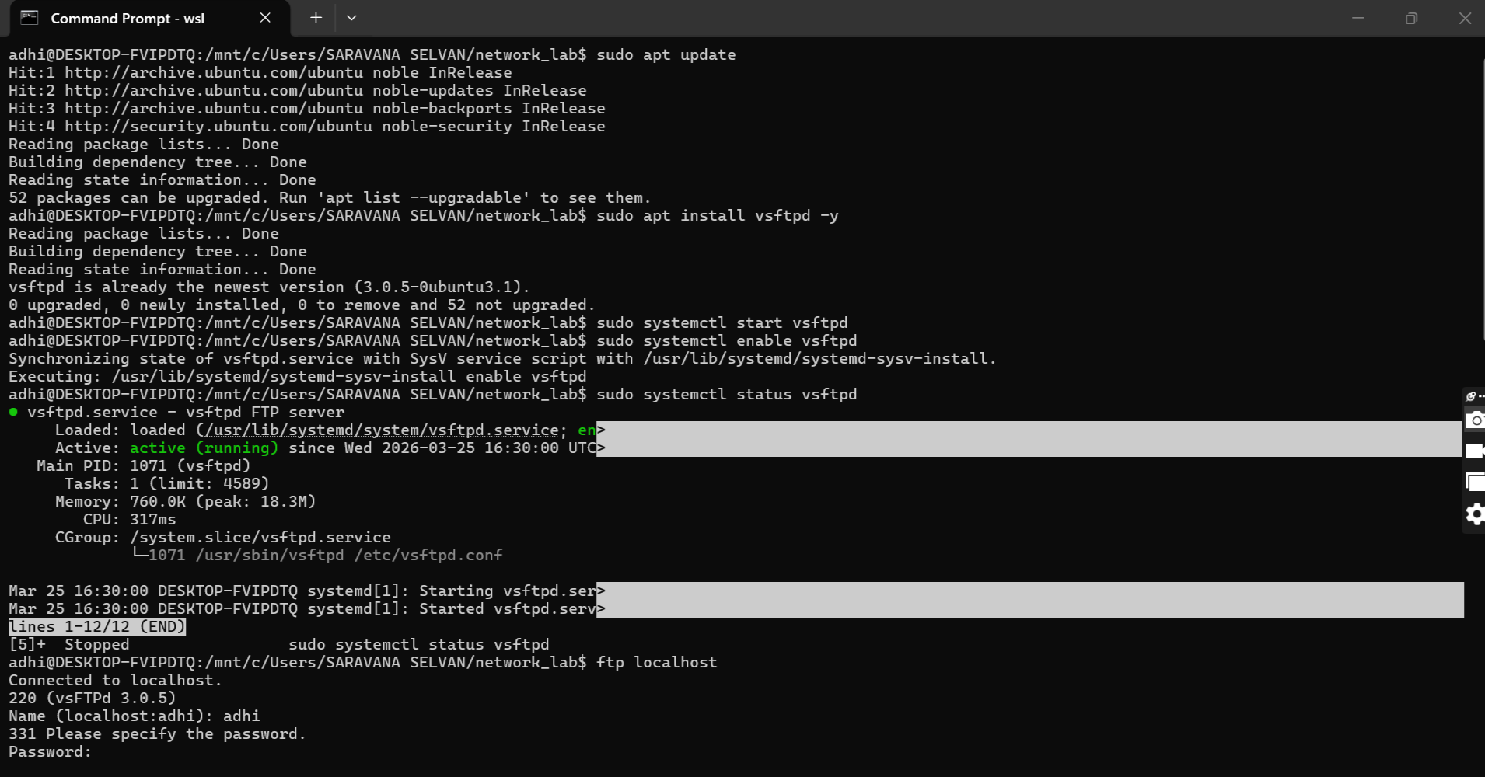
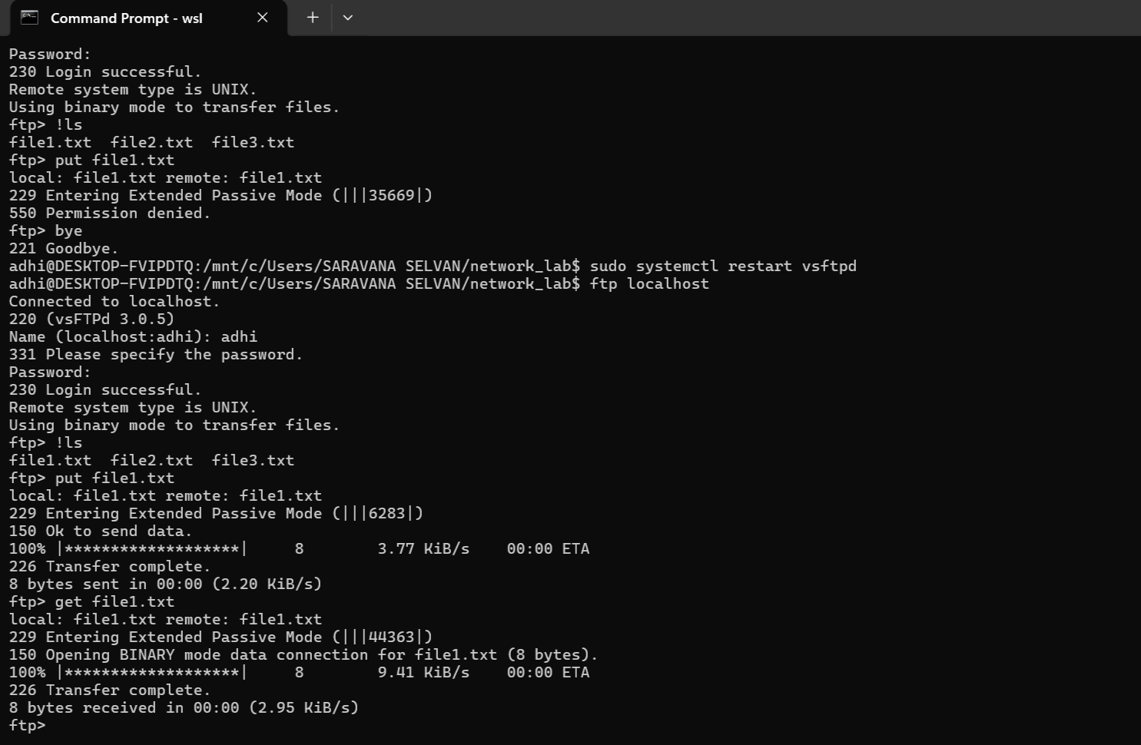
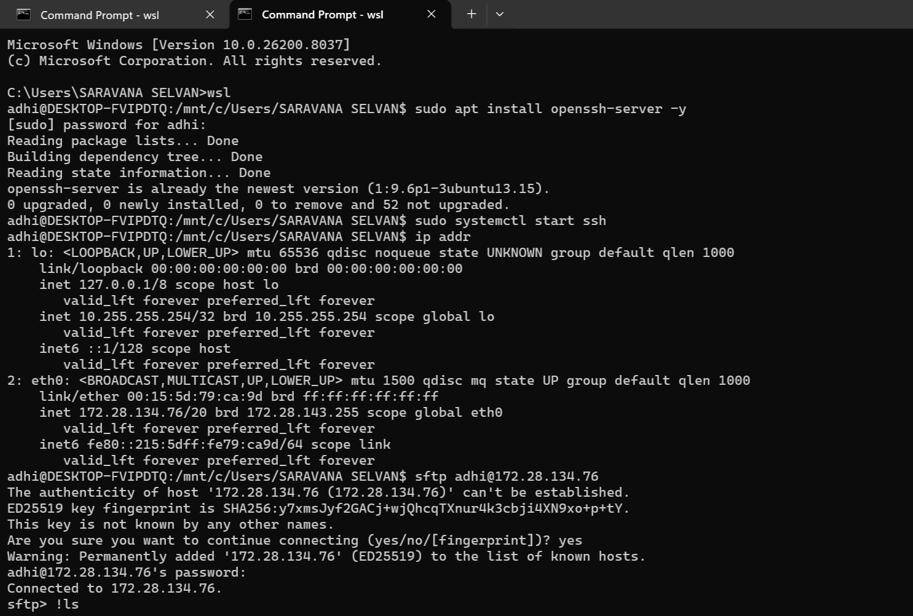
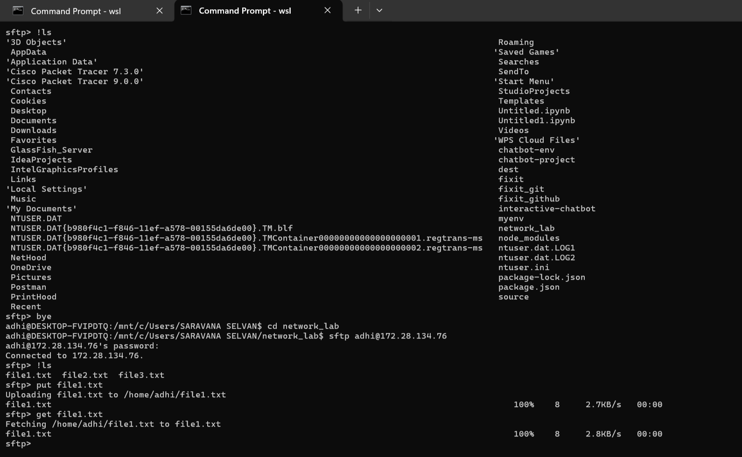
3.
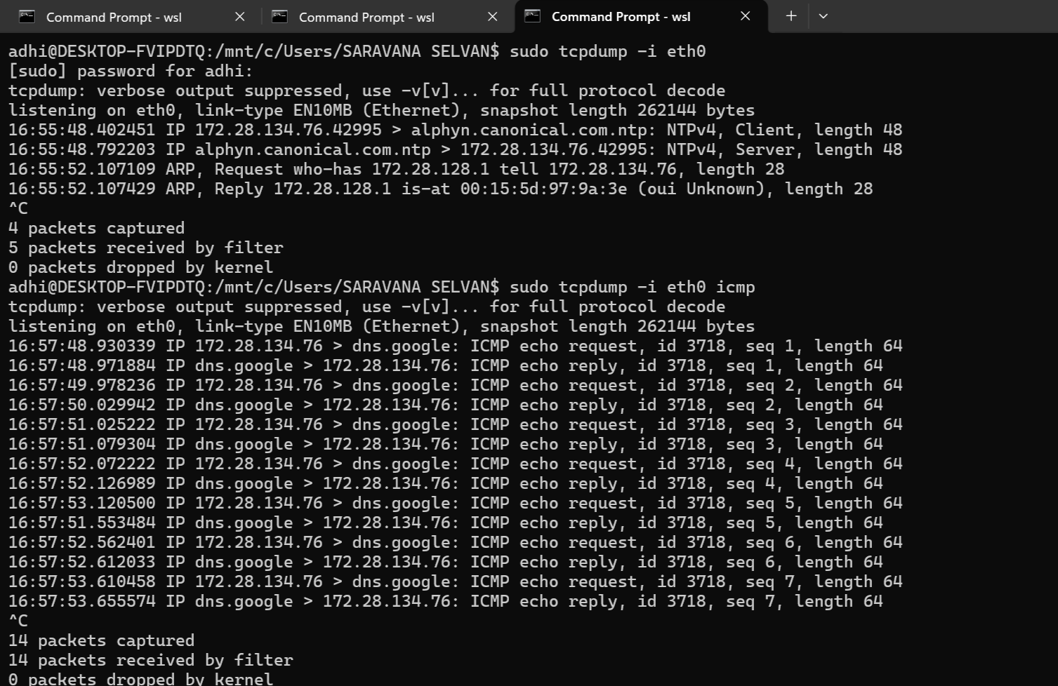
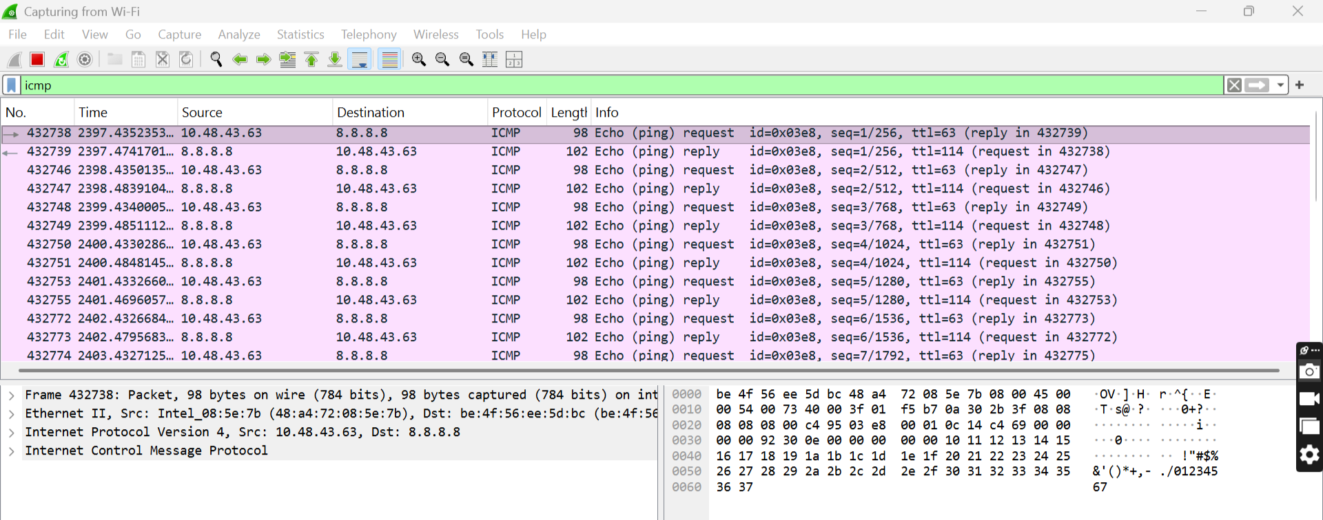
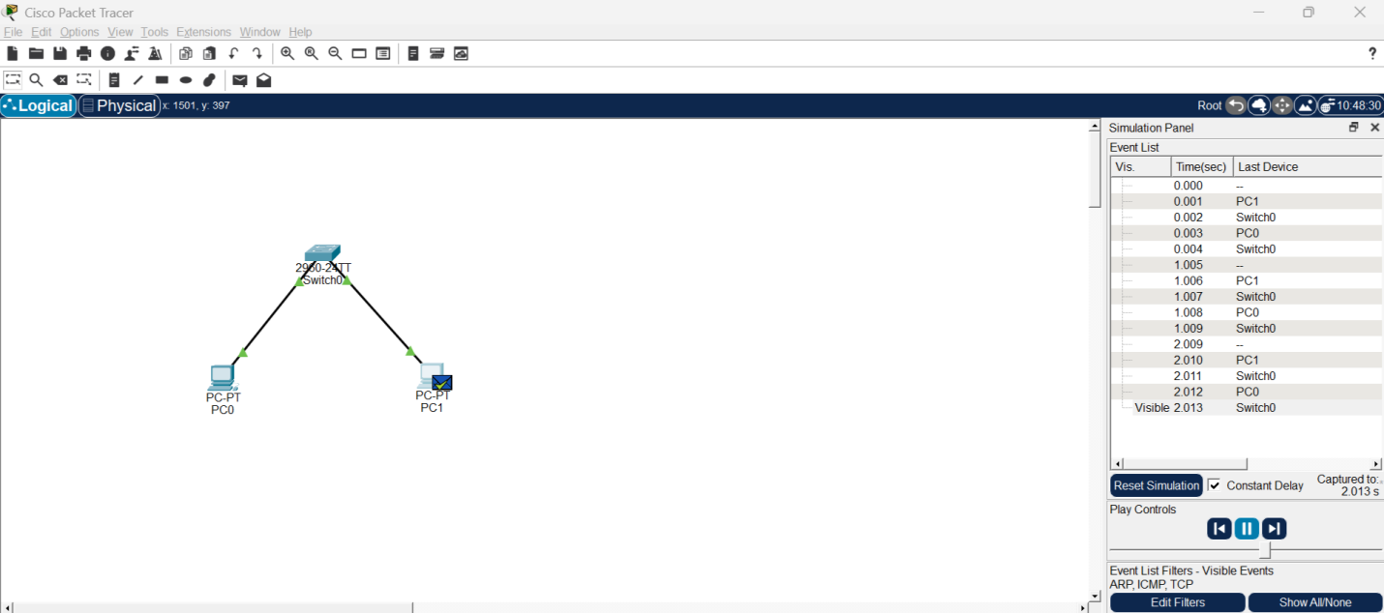
4.
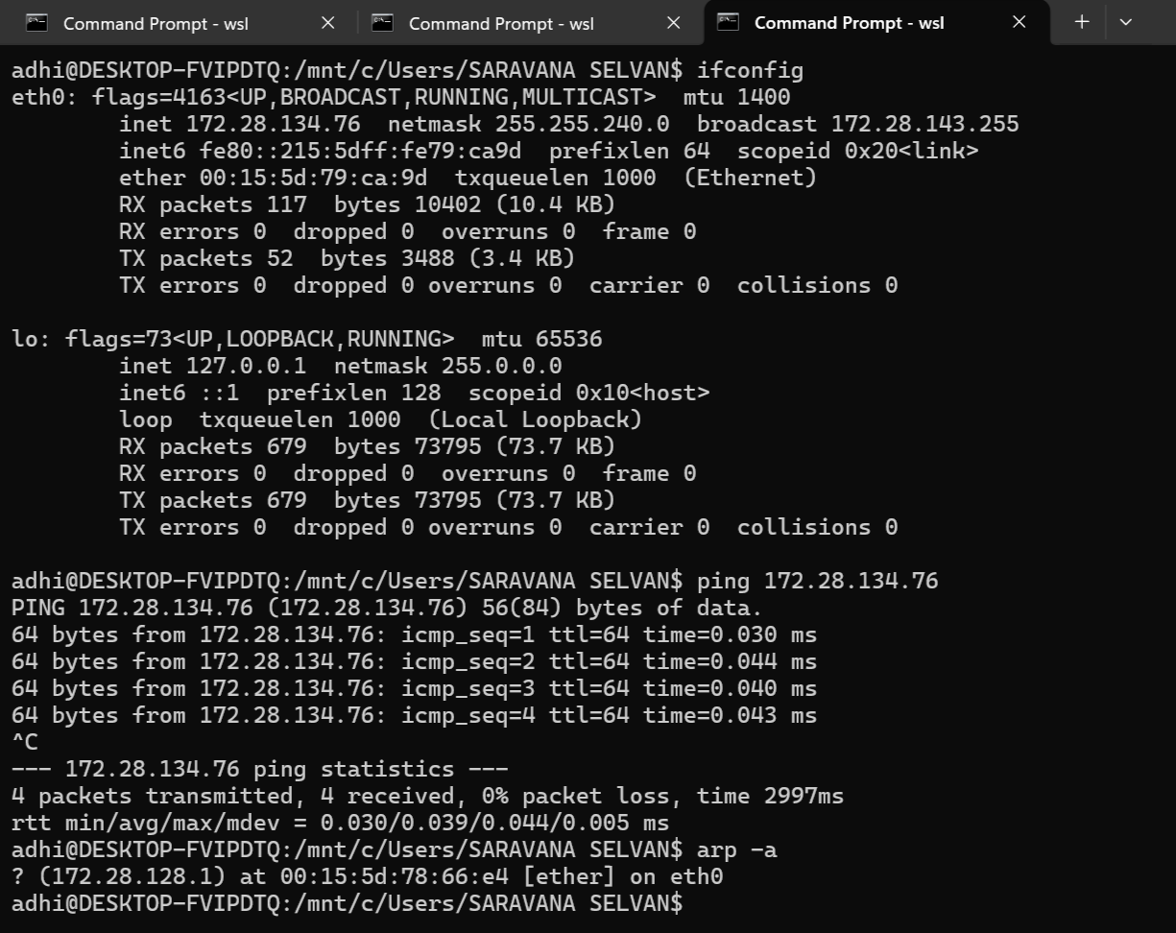

5. How to detect duplicate IP?

Method 1: Using arp
arp -a
Same IP with different MAC addresses

Method 2: Using ping
Unstable replies

Method 3: Router warning

How to fix it?
- Assign unique IP to each device
- Use DHCP instead of manual IP
- Check network before assigning IP

In Cisco Packet Tracer
If you give same IP to both PCs:
- Ping will behave inconsistently
- ARP table will keep changing

Final Answer
Duplicate IP occurs when two devices share the same IP address. This causes ARP conflicts, packet loss, and unstable communication. The network cannot correctly deliver packets, leading to intermittent connectivity issues.
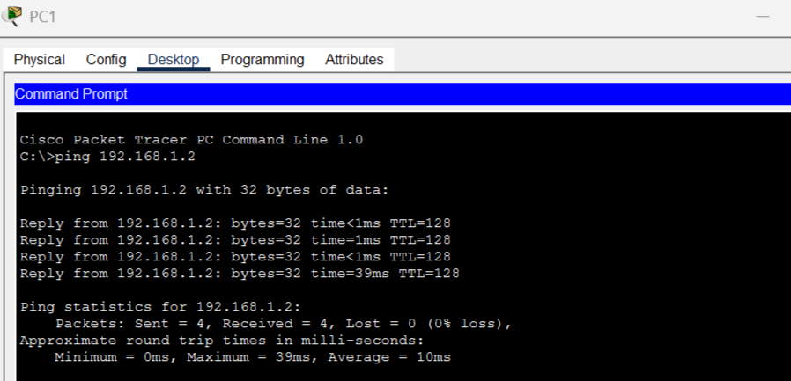
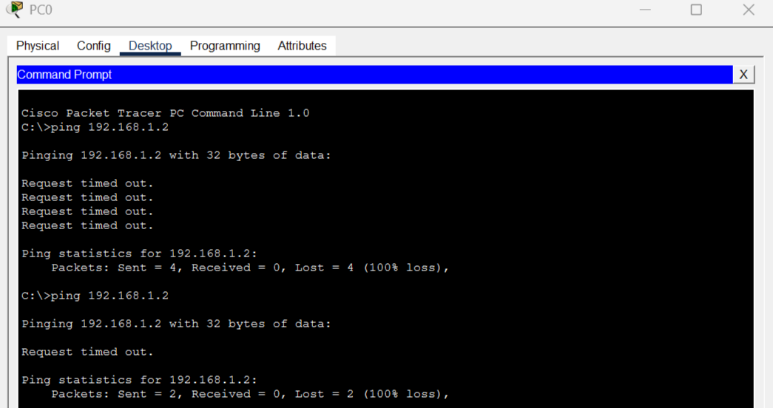
6. Anydesk
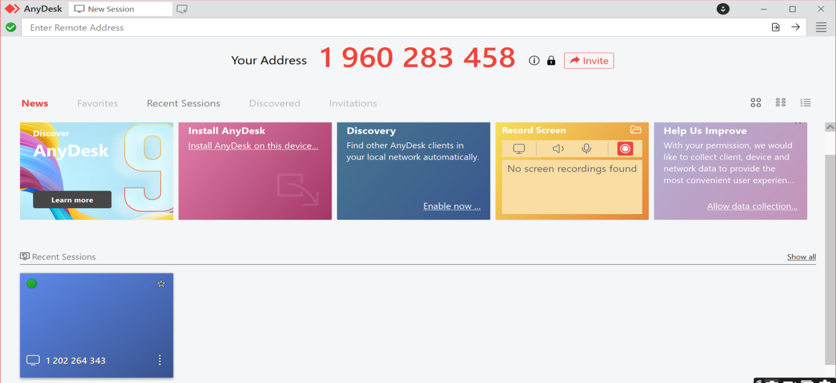
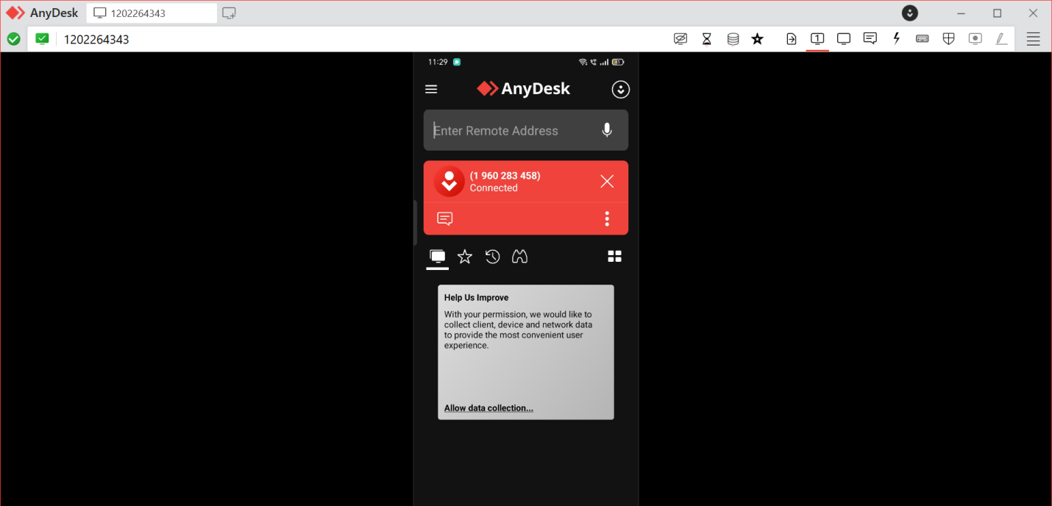
7. A Default Gateway is the device (usually a router) that connects your local network to other networks (like the Internet)
In Linux :
Method 1 : ip route
Method 2 : route –n
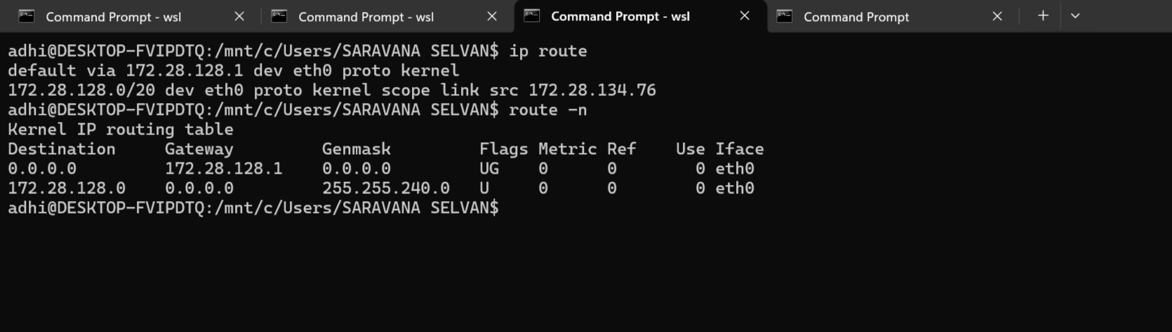
In Windows :
ipconfig
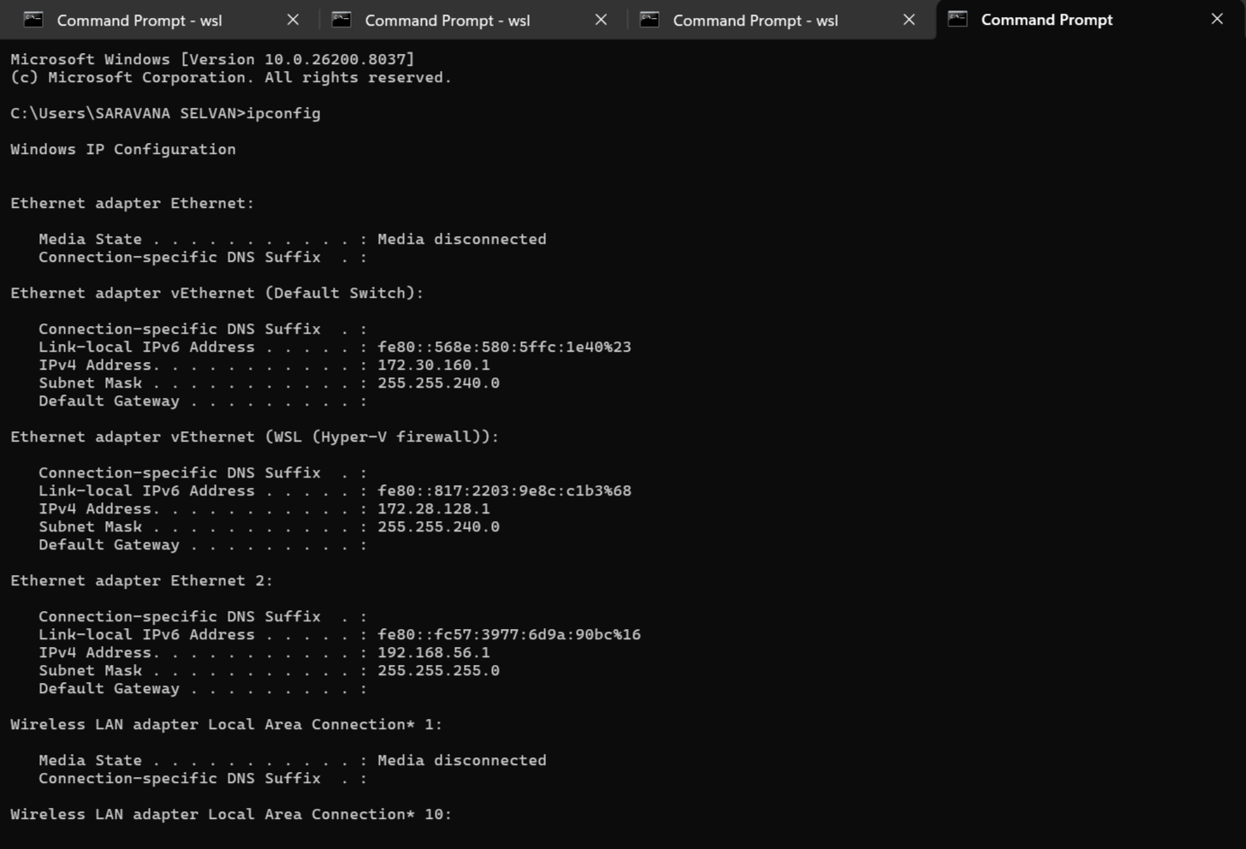
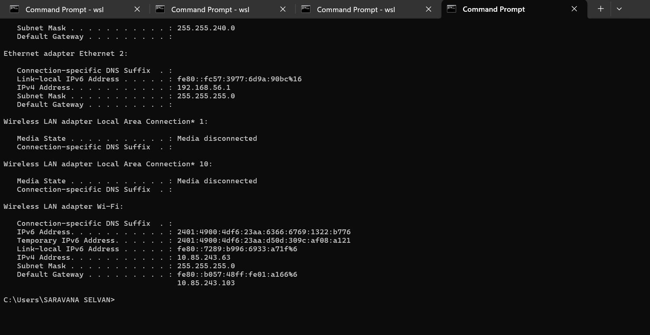
8. DNS (Domain Name System) is a system that converts domain names → IP addresses

How DNS works (step-by-step)
- You enter website name
- Request goes to DNS server
- DNS returns IP address
- Browser connects to that IP
How to test DNS ?
Method 1 : ping (basic test)
Method 2 : nslookup (best method)
Method 3 : dig (advanced)
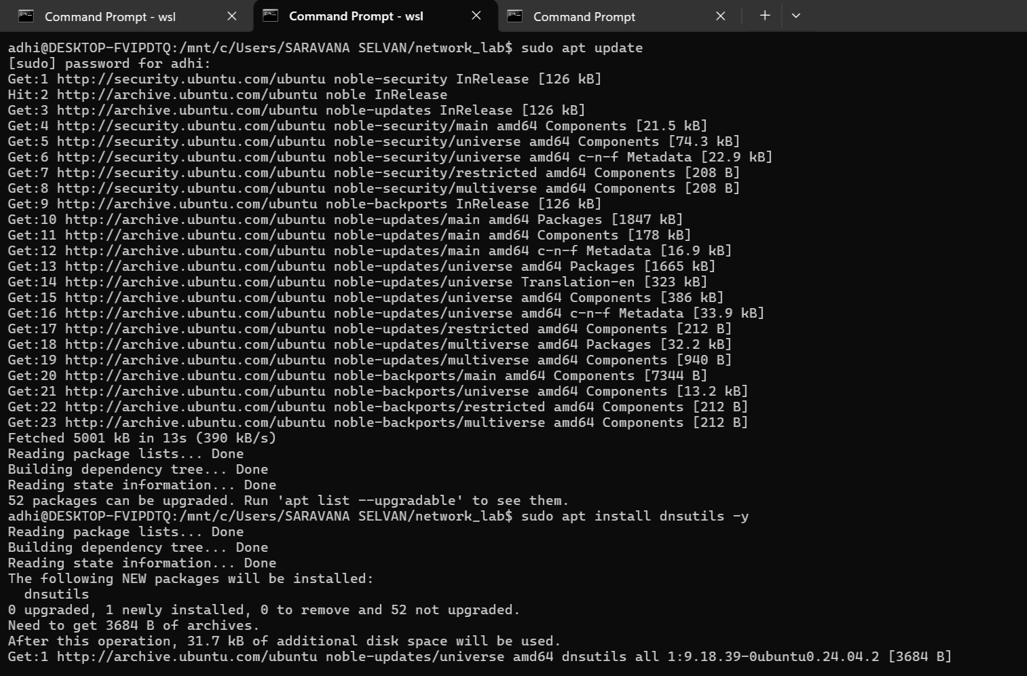

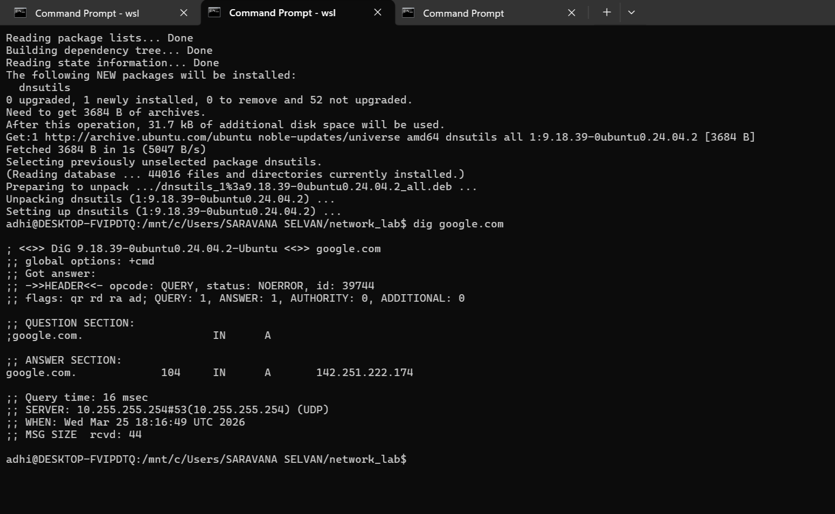
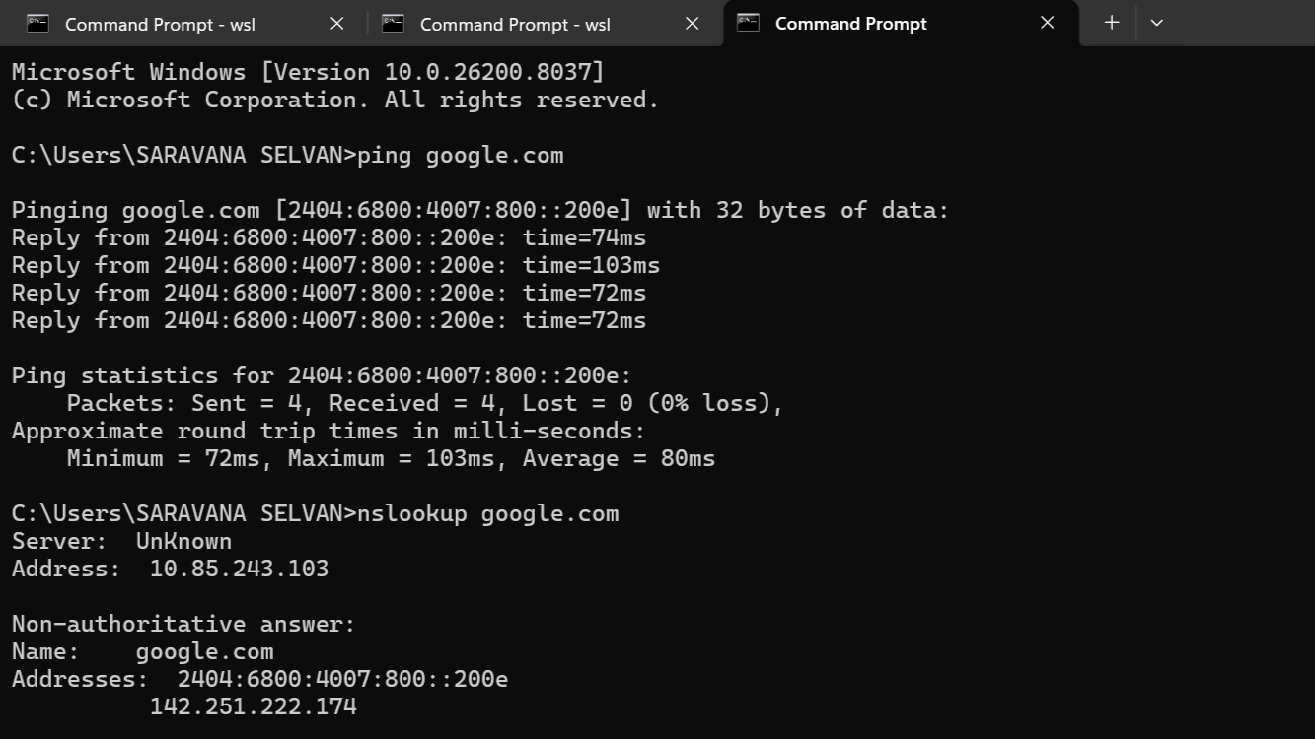
9. DHCP (Dynamic Host Configuration Protocol) is a protocol that automatically assigns IP addresses to devices in a network.
How DHCP works :
Uses a 4-step process called DORA Process

1. Discover
- Client sends request: “Is any DHCP server available?”

2. Offer
- Server replies:“I can give you this IP: 192.168.1.10”

3. Request
- Client says: “I accept this IP”

4. Acknowledge
- Server confirms:“IP assigned successfully”

Example
Device connects to Wi-Fi:
DHCP assigns:
- IP: 192.168.1.10
- Gateway: 192.168.1.1
- DNS: 8.8.8.8

DHCP Ports
- Client → Server: Port 67
- Server → Client: Port 68
Uses UDP protocol
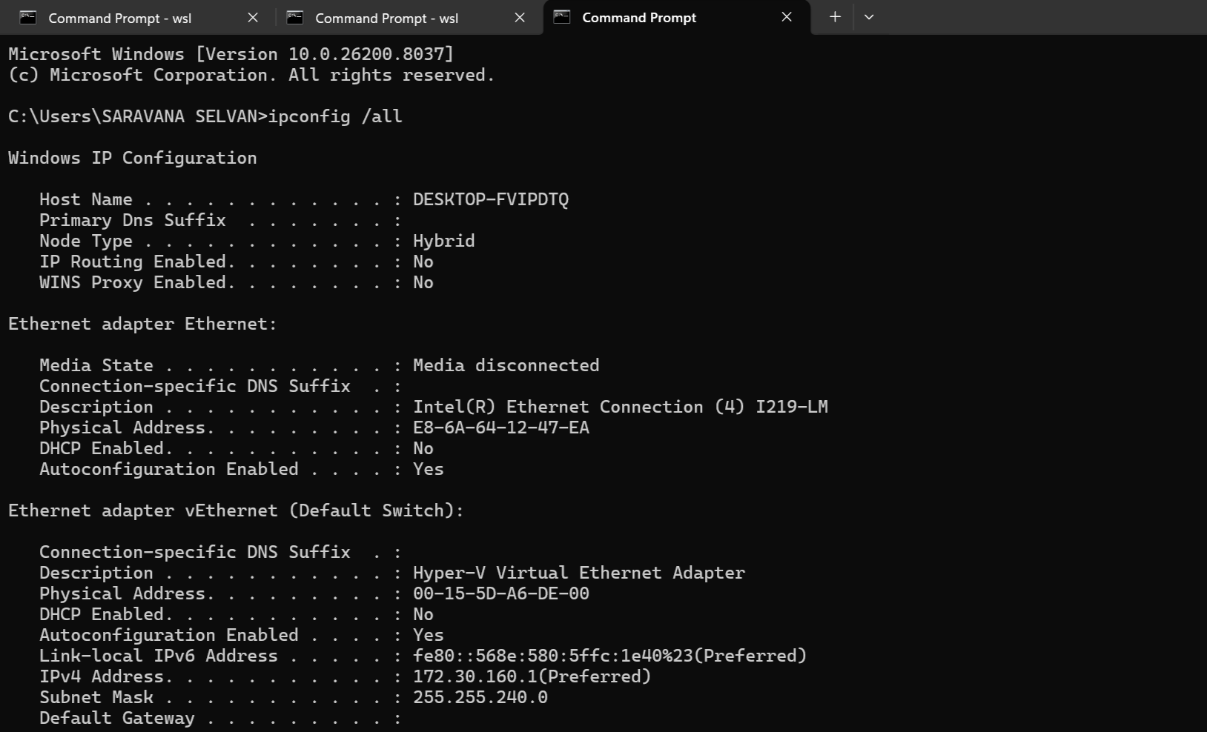
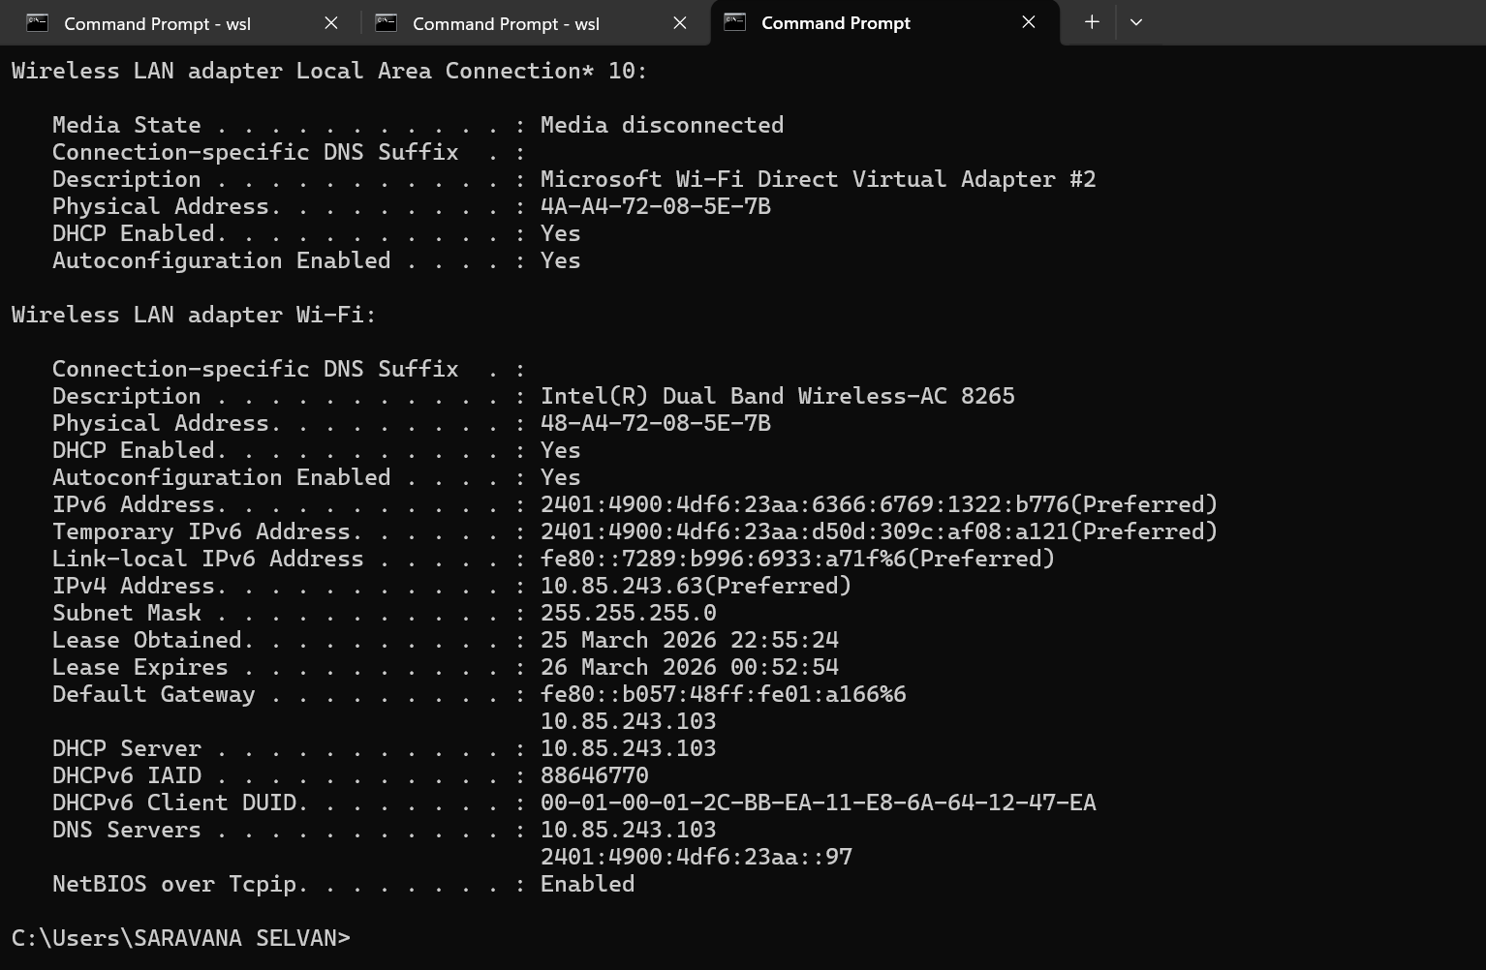
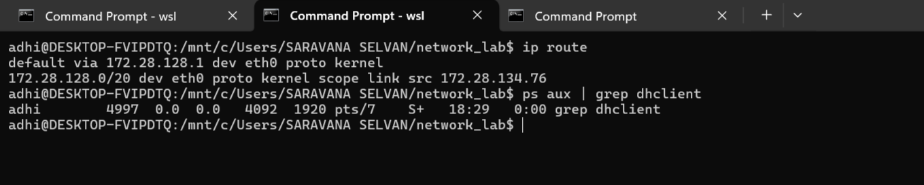

10. NAT (Network Address Translation) is a technique used to convert private IP addresses into public IP addresses.
How NAT works (step-by-step)

Example
- Your PC → 192.168.1.10
- Website → 8.8.8.8

Step 1:
PC sends request to router

Step 2:
Router (NAT):
- Replaces private IP with public IP
192.168.1.10 → 203.x.x.x

Step 3:
Internet sends response back

Step 4:
Router converts back:
203.x.x.x → 192.168.1.10
Data reaches correct device

11. A Firewall is a security system that monitors and controls incoming and outgoing network traffic

How Firewall works
Firewall uses rules (filters)

Step-by-step:
- Packet comes to system
- Firewall checks rules:
  - IP address
  - Port number
  - Protocol
- Decision:
  - Allow ✅
  - Block ❌

Types of Firewall
Type | Description
Packet Filtering | Checks basic info (IP, port)
Stateful Firewall | Tracks connection state
Proxy Firewall | Acts as intermediary
Hardware Firewall | Physical device (router)
Software Firewall | Installed in system

Example
Blocking a port:
- Block port 21 → FTP blocked
- Block port 80 → Website blocked
In our system :
Windows Firewall
- Built-in firewall
- Controls apps & ports

